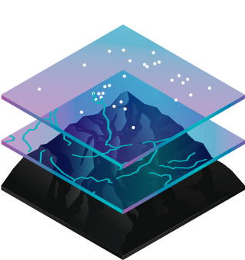Objective:

Make a Demographic Map of Gainesville using 2010 Census Data.

Through this process, we will go through the basics of ArcMap including:

* Workspace Setup
* Adding Basemaps/Data Layer to Scene
* Viewing Attribute Tables
* Changing Symbology
* Selecting Features

Background:

Geographic Information Systems (GIS) are software tools designed to store, analyze, and present geospatial data in one unified system. In GIS analysis, different pieces of geospatial data (**layers)** are arranged, manipulated, and overlaid to understand a topic more completely. Conceptually, separate pieces of geographic information are generally stored in spreadsheets or shapefiles, which make up data layers(.shp, .shx, .dbf file extensions)**;** these layers are stored within a **geodatabase** (.gdb).

Methods:

Step 1:

Download Data Zip File from GitHUB Link on Facebook Page

Step 2:

Go to UF APPS - <https://apps.ufl.edu/Citrix/UFAppsWeb/>

Search for and open M DRIVE on UF APPS

Move SNU Files to your M DRIVE

Step 3:

Search for and open ArcMAP on UF APPS

Step 4:

Create New Blank Scene

Step 5:

Add a OpenStreetMaps Basemap

File -> Add Data -> Add Basemap -> OpenStreetMap

Step 6:

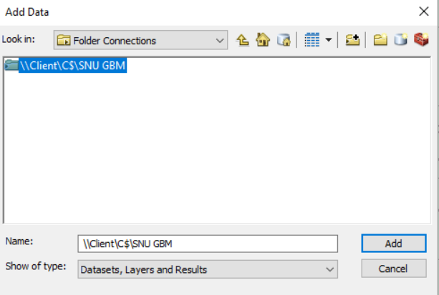Add SNU Folder to Folder Connections

- File -> Add Data -> Add Data

- From dropdown list, select folder connections

- Click “Connect to Folder Icon” (Red Box)

- Add SNU Folder (Located under UFAPPS -> MDRIVE)

Step 7:

Add Census Shapefile to Map

- File - > Add Data -> Add Data -> Folder Connections -> SNU Folder -> Census.gdb -> Add Census

Step 8:

Add Gainesville City Boundaries

File -> Add Data -> Add Data -> Folder Connections -> SNU Folder ->GainesvilleCityLim Folder -> Add shapefile

Step 9:

View Census Attribute Table

Right Click Census Layer -> Open Attribute Table

This table shows all of the data stored within the layer. Information about the data can be found in the Metadata.

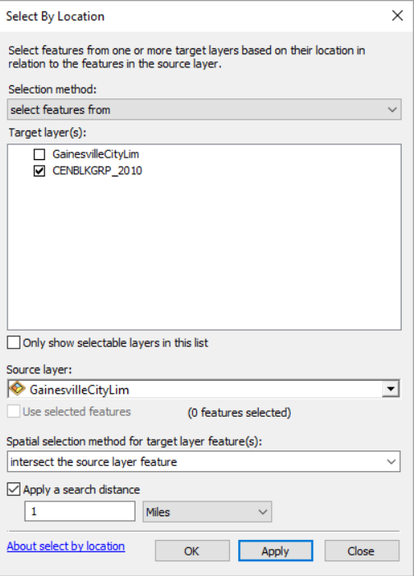

Step 10:

Select Census Blocks within Gainesville City Limits

Selection -> Select by Location -> Match Picture

Step 11:

Make Layer from Selection

Right Click Census Layer -> Selection -> Create Layer From Selected Features

Uncheck old census file, change drawing order with City Limits above Census Data (drag)

Step 12:

Change Symbology of City Limits

Right Click City Limits Layer -> Properties -> Symbology Tab -> Click box under symbol heading

Change Fill Color to Transparent, Change Outline Width to 2

Step 13:

Right Click Census Selection Layer - > Properties -> Symbology ->Click box under symbol heading

Select Quantities -> Graduated Colors -> Match Below

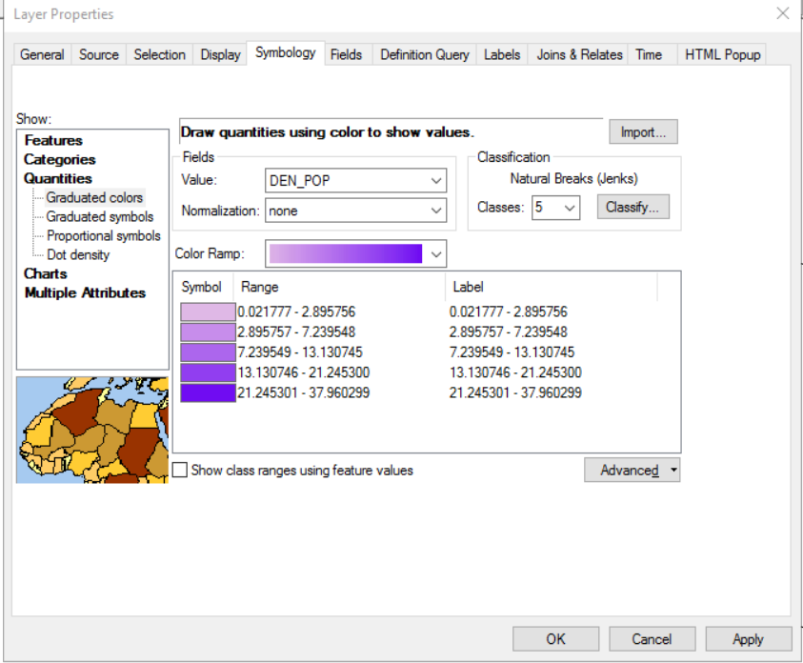

Your map should now show the population density of Gainesville’s Census Blocks. Different data can be selected through the changing of values in the symbology tab, similar to the process we did in the previous step.

Summary:

In this workshop you learned the basics of setting up a scene, adding data to a scene, selecting features, and editing symbology. This is the simplest analysis possible in ArcGIS and still provides a wealth of information that would be missed from a spreadsheet alone.